Name: | Vasundhara Singh
UID no.: | 2021700062
Experiment No. | 10
Class: | SE CSE(DS)
Batch: | D-4
Date of Experiment: | 17/04/2023

AIM: | To implement Rabin Karp’s String Matching Algorithm.
PROBLEM STATEMENT: | Write a C program which matches a given pattern to a given sequence and outputs the position in the sequence at which the pattern exists.
THEORY: | Comparing numbers is easier and cheaper than comparing strings. Rabin Karp algorithm represents strings in numbers.  Suppose p represents values corresponding to pattern P[1…m] of length m. And t_{s} represents values of m-length substrings T[(s + 1) … (s + m)] for s = 0, 1, 2, …, n – m.  We can compute p in O(m) time and all t_{s} can be computed in O(n – m + 1) time.  Rabin Karp algorithm is based on hashing technique. It first computes the hash value of p and t_{s}. If hash values are same, i.e. if hash(p) = hash(t_{s}), we check the equality of inverse hash similar to a naïve method. If hash values are not same, no need to compare actual string.  On the hash match, actual characters of both strings are compared using brute force approach. If the pattern is found, then it is called hit. Otherwise, it is called a spurious hit.  For example, let us consider the hash value of string T = ABCDE is 38 and hash of string P = ABCDX is 71. Clearly, hash values are not same, so strings cannot be same. Brute force approach does five comparisons whereas Rabin Karp dose only one comparison.  However, the same hash value does not ensure the string match. Two different strings can have same hash values. That is why we need to compare them character by character on hash hit.
PROGRAM: | #include <stdio.h>  int main()  {  int q, ns, np, p=0, s=0;  int i=0, index=0, sp_hit=0;  char ch;  printf("\nEnter length of sequence: ");  scanf("%d", &ns);  int seq[ns], hit[ns];  printf("Enter sequence: ");  scanf("%c", &ch);  for(i=0; i<ns; i++)  {  scanf("%c", &ch);  seq[i] = ch;  hit[i] = ns+100;  }  printf("Enter length of pattern: ");  scanf("%d", &np);  int pat[np];  printf("Enter pattern: ");  scanf("%c", &ch);  for(i=0; i<np; i++)  {  scanf("%c", &ch);  pat[i] = ch;  p = p*10 + pat[i];  }  printf("Enter hash key value: ");  scanf("%d", &q);  int hashT[ns-1], hashP;  hashP = p%q;  printf("\nShift | Sequence | Hash\t |\n");  printf("----------------------------------------------------------\n");  for(i=0; i<ns; i++)  {  printf("%d\t|\t%c\t|\t", i, (char)seq[i]);  s=0;  for(int k=i; k<i+np; k++)  {  s = s*10 + seq[k];  }  hashT[i] = s%q;  if(i!=ns-1)  printf("%d\t | ",hashT[i]);  if(hashT[i] == hashP)  {  printf("Hit\t");  for(int j=0; j<np; j++)  {  if(seq[i+j] != pat[j])  {  printf("(Spurious)");  sp_hit++;  goto next;  }  }  printf("(Valid)");  hit[index] = i;  index++;  }  next:  printf("\n");  }  for(i=0; hit[i]<ns; i++)  {  printf("\nString found at shift %d", hit[i]);  }  printf("\nNo. of valid hits: %d", i);  printf("\nNo. of spurious hits: %d\n\n", sp_hit);  }  //3141592653589793  //cxyzghxyzvjkxyz
RESULT: | For integer sequence: -  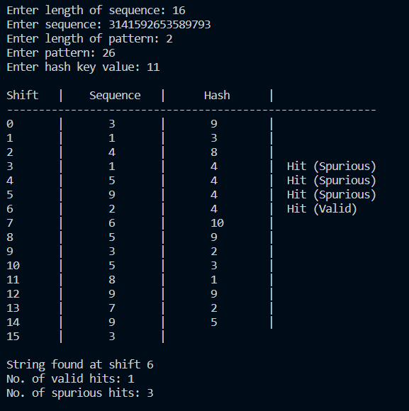  For character sequence: -  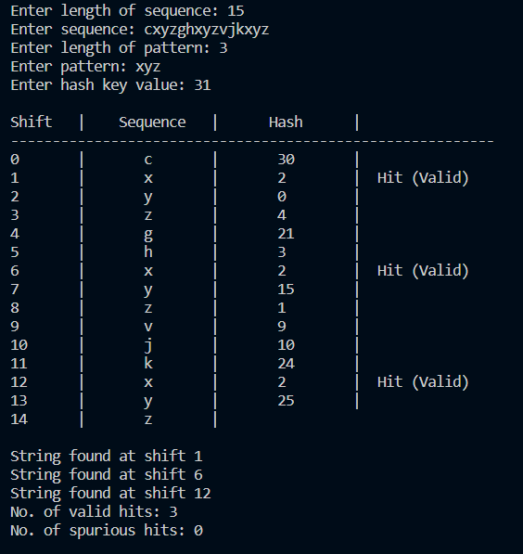
CONCLUSION: | We are able to implement Rabin Karp’s Algorithm.

